Sweet FINK
We have relocated to the rear of FINK and are delighted to say that, whilst we may have a little less space, we still have an amazing array of delicious sweet treats!
Fink Home & Nature
Find us at 32 High Street where our mantra is ‘Reuse – Refill – Respect’. On the Home side we have a range of natural skin and hair care products, and gifts for your home and loved ones. All are ethically sourced and kind to the environment. On the Nature side you’ll find treats for your pets and garden birds – bring your own containers and we’ll give you an extra saving
December/Christmas opening
FINK/SweetFINK as usual plus
Wednesday 6th 6am – 8pm
Sunday 23rd 10am – 4pm
Monday 24th 6am – 4pm
Tuesday 25th – Thursday 27th CLOSED
Monday 31st – 6am – 4pm
Tuesday 1st January CLOSED
FINK Home & Nature as usual plus
Wednesday 6th 9am – 8pm
Monday 24th 9am – 2pm
Tuesday 25th – Tuesday 1st January CLOSED
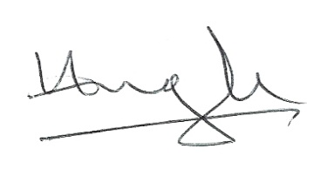
See you soon.

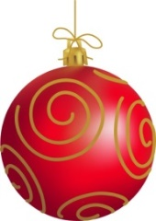
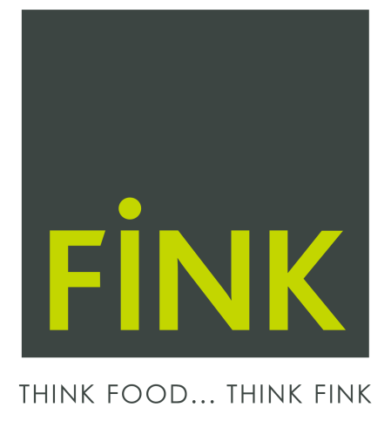
Hugh Fink & Sharon Longcroft
14 High Street, Boroughbridge
01423 324188
info@thinkfink.co.uk
Hello
About Your Christmas Food Orders
EARLY ORDERS GET DISCOUNTS!
As usual, we can supply nearly everything you’ll need for your Christmas feasts.
To save you time, why not order in advance? We’ll need your order no later than 19th December (16th December for chilled dairy, smokehouse, pates, coleslaw etc). We can also deliver (for free within the YO51 postal area) but please do let us have your order as early as possible to take advantage of this service.
Every fruit and veg order worth over £10 will receive a 10% discount, and if you order by 30th November we’ll give you an additional 5% off*.
If you want something that you aren’t sure we can supply please call in or get in touch as soon as possible and we’ll do our best to source it for you.
You can phone (324188), email (info@thinkfink.co.uk), or drop off your order in person. There is a list of products attached but we offer a huge range so please feel free to add any items that are not list, or contact us if you are not sure we sell it.
*Discounts apply to greengrocery goods only
Potatoes: Roasting, Mashing, New/scraping
This is just a prompt – feel free to add additional items
Think Christmas. . .
Brussels sprouts: on stalk/loose
Cabbage – red, white, savoy, sweetheart type, other
Carrots: Regular loose/Chantenay/Bunches
Cauliflower/Broccoli
Chestnuts: fresh, vacuum, puree
Fine Beans
Onions – salad, red, white, sweet white, Spanish, garlic
Parsnips, swede
Peppers
Salad: Mixed leaf, iceberg, little gem, rocket, watercress, cucumber
Shallots
Spinach (packs)
Lemons, limes
Grapes, seedless red/white
Melon: Honeydew, Galia
Cranberries, fresh (punnets)
Other (e.g. Strawberries, raspberries, cherries, kiwis, passion fruit, cape gooseberry)
Cream: single, double, whipping, soured, clotted, crème fraiche
Butter: Acorn organic, Longley Farm Jersey, unsalted
. . .Think FINK!
Smoked products: salmon, chicken, duck etc.
Bacon & sausages: smoked/unsmoked back/streaky, sausagemeat, cocktail sausages
Milk – Acorn organic, whole, semi skimmed, skimmed, pint bottles or 0.5/1/2 litre plastic
Patés, coleslaw
Fish & shellfish by Ramus: whole salmon/steaks, white fish, smoked fish, lobster, crab, seafood platters etc.
Nut roasts/stuffing mixes
Sugar snap peas/mange tout
Tomatoes – loose, vine, cherry vine
Other (e.g. asparagus, sweet potato, butternut squash)
Apples: Cox, Braeburn, Granny Smith, Golden Delicious, Pink Lady, Bramley
Oranges/Grapefruit/Satsumas/Clementines
Relishes/condiments
Tea & coffee
Cake, biscuits, breads, pastries
Party food: nibbles, popping corn, dips
Drinks: juices, cordials, mixers, mulled wine spice
And for chocolates, think Sweet FINK!

